Safety Instructions

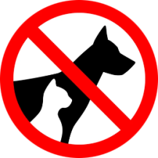 | Pet clothes and shoes are strictly forbidden to be washed and dried.
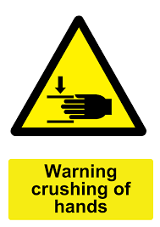 | Do not approach your hands close and around the washer door when the machine washes and especially when the machine spins.
 | Do not overload the machines beyond their nominal value.
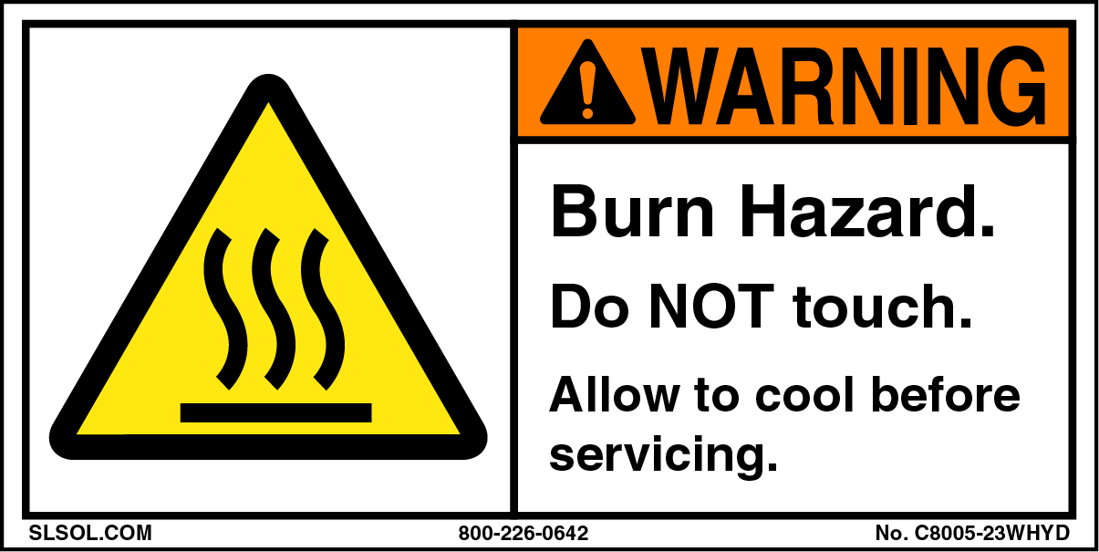 | Do not touch the doors and the panels of the dryers when they dry. Danger of burn.
 | You can open the door of the dryer at any time. Do it carefully and gradually.  It is strongly advised to press the pause symbol || and after checking press the green Start arrow that will appear on the screen after closing the door.
 | Do not put in the dryers clothes that are treated with chemicals like gasoline. You should first wash clothes treated in this way.
 | For your safety but also for perfect results detergents are automatically presented in the washing machines.  The clothes rinse 3 times to avoid any detergent residues. We care for you and for the environment.
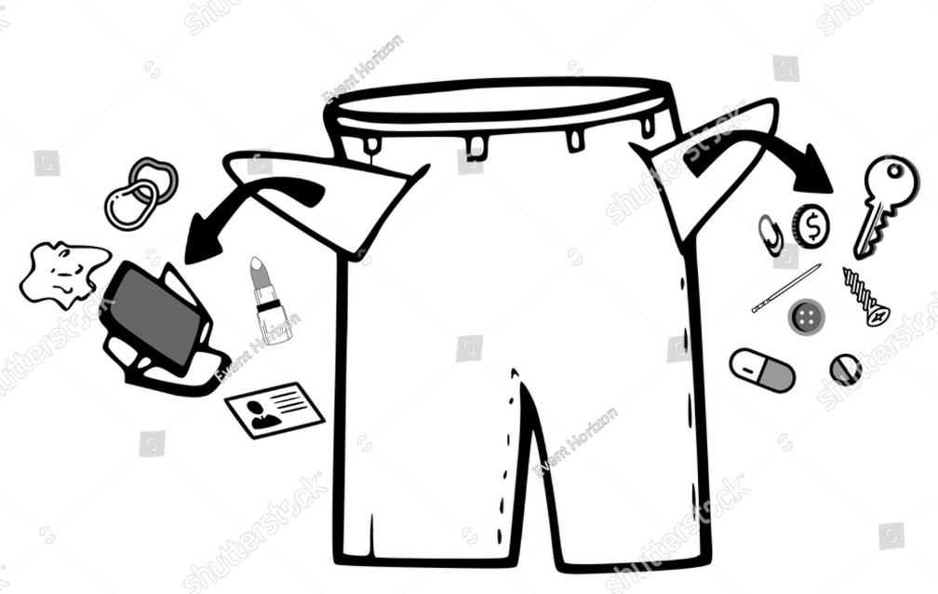 | Empty your pockets before putting your clothes in the machine!

